

LinkedIn Grad - Start your career

**Background**

Several graduated students have faced a lot of difficulties looking for their first job that is suitable with their professional skills as well as their expectation in the future. The primary reasons are a lack of soft skills like interview or negotiation, no experience in working environment in businesses and career path’s direction.

**Product**

Mobile application named LinkedIn Grad provides many features related to enhancing freshers’ skills and preferences. Several benefits can be reaped from our application such as job recommendations, creating and reviewing resumes, and online courses.

**Key Features**

1. **Resume**

* CV’s system for users to upgrade their resume with the suggestion from AI.
* This is a crucial feature to build the fundamental background for users and attract the recruiters.
* Increase the acceptance rate of the 1st round (CV)

1. **Online Course**

* Training courses provide a lot of information for freshers to enhance their professional skills (marketing, computer science,...) and their soft skills (interview, presentation, negotiation, …)
* This is a supportive foundation that helps college graduates be outstanding in the next stages.

1. **Job Recommendation**

* Based on the professional and soft skills as well as the created resume, there are several suggestions about the suitable jobs for students.
* This is a vital step in the process of applying for a job, which could have positive impacts on the result of acceptance rate.
* Feature allows freshers to access the potential career of their aspects and directs them to follow.

**Post-Launch Insight**

LinkedIn Grad is the favorite feature of users, who could find out their career after creating an excellent resume and completing online courses. We launched this mobile application in Vietnam 1 year ago and currently have 300K sign ups and 100K membership.

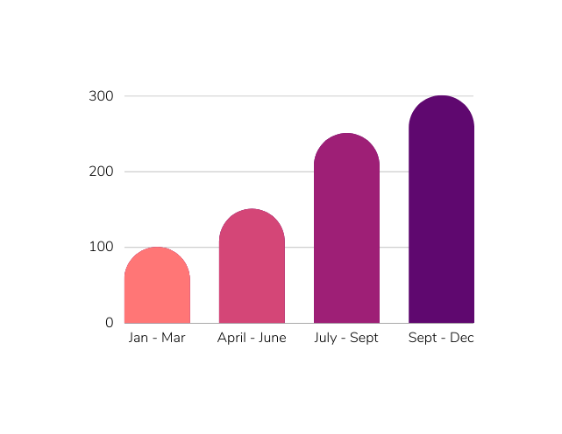

**Next Steps**

1. We will expand the market to China, Thailand, Singapore and Philippines, which have similar local culture and a high percentage of graduated students.
2. Adding new features:
   1. Notification for users (students and recruiters)
   2. Translation (Thailand Market)
   3. Graph for matching rate between recruiters’ expectation and students’ skills and preferences.

This launch would not be possible without hardworking journey of all members of our team and I’d like to thank all members of projects:

* Development team
* QA team
* Product Designer
* Product Marketing Manager
* Customer Services
* Legal and Terms team.

Best Regards,

Bich Pham

Product Manager